Spring 2017 ECON 6460
Agriculture and Sustainable Development Midterm Exam v 4.3

(due April 20th 2017) Please use the template version of this exam (not this pdf version) to add your answers after each? in a different font, Answer 1.1 to 1.3. All sections/questions in italics are extra credit.

MQ-1.1 Climate shocks and Resilient seeds: The 2016 WESS report argues resilience can reduce inequality (and that climate change can increase inequality). (a) DESA may not mention it (please check) but the Swarna-Sub1 (SS1) rice variety now being adopted by millions of farmers in India is a perfect example of how resilience reduces inequality. Why do scheduled castes benefit most from SSI seeds? (b) UNDP has more demanding definition of resilience as a “transformative process of strengthening the capacity of people, communities and countries to anticipate, manage, recover and transform from shocks” also known as “build back better.” Explain how farmers how SS1 leads to a 2nd green revolution even though average yields rise only slightly (hint “crowding in” see Emerick et al, 2016). (d) NERICA-3 may also shorten the lean season in Sierra Leone, or it may not (see Glennerster and Suri, 2015 ). Referring to the WDR 2008 Chapter 7 especially “Focus E capturing the benefits of genetically modified organisms for the poor” how do NERICA’s travails in Africa illustrate the broader problems GMOs face in Africa? Why have GMOs been so successful in Asia and in the Americas but more or less failed in Africa? (China is moving to large corporate farms is just bought high tech seed company Syngenta. Why might Chinese scientists be more successful in introducing the green revolution in Africa? (e) EC: Use the DESA diagram Figure II.2 below to explain how floods increase the asset gap between the rich and the poor in NOLA or BGD. SS1 is a partial solution, what other policy intervention are needed to reduce inequality, consistent with COP21)?

MQ1.2 Gender and health in Bangladesh: (a) In his video on BGD Hans Rosling advances a pure health and demographics “Bangladesh miracle” (Mobarak, Heath and Kabeer also focus on women’s empowerment). Add data to Rosling’s argument with reference to the Global Monitoring Report pages 180 and 236 Table C.3. the DHS fertility data in the Bangladesh lecture notes. (b) Pitt et al. 2012 argue health and openness driven development benefit women, while agricultural development favors men. Briefly summarize this “brawn vs brain” argument. How do health, agricultural innovation and openness all end up advancing women’s education? (hint: brains vs Brawn). Similarly “worms at work” (WAW or Baird et. al. 2016) says Kenyan “Women who were eligible as girls are 25% more likely to have attended secondary school, halving the gender gap” referring to girls who were in the “Busia district, a densely-settled farming region in western Kenya adjacent to Lake Victoria” (see WAW, page 6). How well did women do in other regions of Kenya in closing this gender gap (use the 1998 and the 2014 or 2008-09 DHS national or district reports for Kenya to answer this question). (c) Indeed, delaying marriage and educating women also seems to be the key to women’s empowerment in Bangladesh, how do Heath and Mubarak (2015) argue this can be done? Yet the World Bank’s NARI project to help young women migrate to cities seems to have failed, why? (the World Bank will tell you, between the lines and see Rachel Heath’s forthcoming JPE paper) If we define women’s empowerment narrowly as freedom from domestic violence, does paid wage employment outside the home empower women in Bangladesh? If now, what does seem to help Bangladeshi women avoid domestic violence. Relate this the findings of Heath and Mobarak in villages near garment factories (for this last section you will need to find the references to Heath’s sole authored papers in Kabeer, 2016 and/see her directly on her webpage).

MQ 1.3 Resilience and Lean Seasons: Post Worm Wars Givewell is considering “No Lean Season” as their potential “top charity” for 2017, succeeding Deworming initiatives (the Lean Season just got an “incubation grant”) See the Bangladesh Case study lecture notes (a) What is the Monga or “lean season” why is it harmful, particularly for poor families? What is Mushfiq Mobarak et al.’s “no lean season” program? This program is less likely to be challenged by the Cochrane Report, but anticipate problems and discuss whether this program has a “brain vs brawn” gender bias? Might this program benefit women more than men (as MPESA apparently does). If your project focuses on villages or rural communities, would transit subsidies in the lean season be appropriate or politically acceptable? (b) Latin America vulnerable households but “highly resilient” implies “no lean season” According to Jemio and Andersen (2013) “resilient” households are both diversified and high income. Surprisingly, female headed households are as or more likely to be “highly resilient” that male headed households, see for example Table 19 on page 20 of Andersen et al. 2014. Relate these findings to the new Economics of Labor Migration (NELM) discussed in class. What do most Bolivians and Mexicans (and Peruvians) have that Bangladeshi families might not have? Suggest ways to supplement remittances and labor income for Lean season families. (c) Sketch the internal and external validity problems that led to “top charity” rise and fall of Kremer and Miguel (2004) deworming intervention. In your view, what would have to happen for deworming to regain its “top charity” status. Does this mean school children should not receive deworming pills?

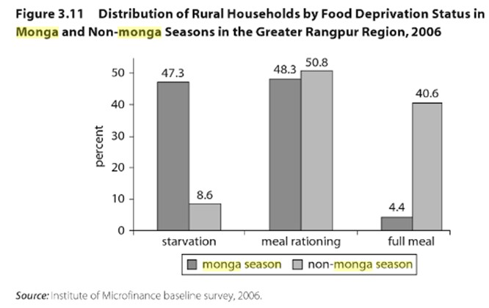
Source: Shahidur R. Khandker, Wahiduddin Mahmud (2012) Seasonal Hunger and Public Policies: Evidence from Northwest Bangladesh, the World Bank.

MQ-1.4 EC Local farm market dynamics: Why has it been so hard to get farmers in Africa to adopt new seed varieties (as opposed to farmers in Asia, who are using Swarna seeds for example). Examples include NERICA in Uganda, fertilizer in Kenya or Mali or the Suri’s influential Econometrica paper (now on the google drive and available online on campus). Start with Suri’s findings and explain them using Figure 18.16 from D&S, 2015 Chapter 18 to explain why we may observe no crowding in when food is not “traded” that is figure (a) applies not figure (b). If farmers in India, poor or not, do face a flat demand curve as in figure (18.26b) why would new seeds “crowd” in new inputs (and raise land prices). Who benefits from higher land prices? Who loses? Explain why Figure 18.26a amplifies the “lean season” problem, but figure b shifts risk to farmers who may become reluctant to take the risk of new varieties (this is a problem in India now, after extensive road building. (hint: how did Ali Zafar solve BFA’s regional famine problem).

MQ-1.5 (a) Returning to (2b) To what extent does deworming’s fall from grace “validate” the “randomista” criticisms of Deaton, Pritchett? What created the “external validity” problem for deworming despite elegant defenses of by Clemens and Sandefur (2015) papers by colleagues and students and various blog posts by Blattman for example (Miguel and Kremer are very good economists…). (b) Sketch out a scenario under which deworming children stages a comeback as a health and education intervention. What makes this comeback unlikely (recall they are prescribing a pill…). What if Il Ninos weather extremes become frequent events?

Green Revolution References: *short briefings, quick reads with nice pictures…

*CGAIR News (2013) “Benefits and burdens of new rice varieties in Uganda” August 7th (see articles on NERICA-4)

*Dar, Manzoor Alain de Janvry, Kyle Emerick, and Elisabeth Sadoulet (2015) “Resilient Rice” J-PAL Policy Briefcase August, 2015.

*Dar et al. (2013) Dar, Manzoor H., Alain de Janvry, Kyle Emerick, David Raitzer, and Elisabeth Sadoulet. "Flood-tolerant rice reduces yield variability and raises expected yield, differentially benefitting socially disadvantaged groups" Scientific reports 3 (2013): 3315.

*Economist (2014) The new green revolution A bigger rice bowl Another green revolution is stirring in the world’s paddy fields May 10th 2014, Los Baños, The Philippines, And Suphan Buri, Thailand.

Emerick et al (2016) Emerick, Kyle, Alain de Janvry, Elisabeth Sadoulet, and Manzoor H. Dar "Technological innovations, downside risk, and the modernization of agriculture." American Economic Review 106, no. 6:1537-61.

*Suri, Tavneet 2015 Rice Experiment Yields Results Tavneet Suri argues NERICA reduced the lean or hunger season

*Glennerster, Rachel and Tavneet Suri (2015 J-PAL and BRAC new seed trail The Impact of New Rice Varieties on Health in Sierra Leone NERICA-3 Rice Growing experiment

Bangladesh: health and agricultural innovation in Bangladesh

Alesina, Alberto, Paola Giuliano, and Nathan Nunn. "On the origins of gender roles: Women and the plough." The Quarterly Journal of Economics 128, no. 2 (2013): 469-530.

Field Erica, Ambrus Attila (2008) Early Marriage, Age at Menarche and Female Schooling Attainment in Bangladesh. Journal of Political Economy;116(5):881–930.

Behrman, Jere and Hoddinott, John and Maluccio, John A. and Martorell, Reynaldo (2009) Brains versus Brawn: Labor Market Returns to Intellectual and Health Human Capital in a Poor Developing Country Available at SSRN: https://ssrn.com/abstract=1471316

Headey, Derek, John Hoddinott, Disha Ali, Roman Tesfaye, and Mekdim Dereje (2015) "The other Asian enigma: explaining the rapid reduction of undernutrition in Bangladesh." World Development 66:749-761,

Heath, Rachel and A. Mushfiq Mobarak (2015) Manufacturing growth and the lives of Bangladeshi women, Journal of Development Economics,115 (2015) 1–15 http://faculty.som.yale.edu/mushfiqmobarak/papers/garments.pdf

Joshi, Shareen; Schultz, T. Paul (2012) : Family planning and women's and children's health: Long term consequences of an outreach program in Matlab, Bangladesh, IZA Discussion Paper series, No. 6551 published in 2013 as Demography 50 (1): 149–80. https://www.econstor.eu/bitstream/10419/58958/1/716017628.pdf

Kabeer, Naila. (2012) Women’s economic empowerment and inclusive growth: labour markets and
enterprise development, SOAS, UK SIG working paper 2012/1
Kabeer, Naila. "Between affiliation and autonomy: navigating pathways of women's empowerment and gender justice in rural Bangladesh." Development and Change 42, no. 2 (2011): 499-528.

Kabeer, Naila. (2016) "Economic pathways to women’s empowerment and active citizenship: what does the evidence from Bangladesh tell us?." The Journal of Development Studies 1-15 [on google drive].

Pitt, Mark M., Mark R. Rosenzweig, and Mohammad Nazmul Hassan (PRH, 2012) "Human capital investment and the gender division of labor in a brawn-based economy." The American economic
review 102, no. 7 (2012): 3531-3560. https://www.ncbi.nlm.nih.gov/pmc/articles/PMC4140409/

Sebastio, Filippo (2014) Female empowerment in the Bangladeshi garment industry

Headey, Derek, John Hoddinott, Disha Ali, Roman Tesfaye, and Mekdim Dereje (2015) "The other Asian enigma: explaining the rapid reduction of undernutrition in Bangladesh." World Development 66:749-761

The Hunger Season

Shahidur R. Khandker, Wahiduddin Mahmud (2012) Seasonal Hunger and Public Policies: Evidence from Northwest Bangladesh, the World Bank.

*The GiveWell Blog, 2017, Why we’re considering No Lean Season as a potential 2017 top charity
*No Lean Season, January 2016 Update and Evidence Action posted on Givewell blog) Phone call notes

Ahmed Mushfiq Mobarak and Agha Ali Akram (2016) Seasonal Migration to Increase Incomes of
Poor Households in Bangladesh, Yale University and Evidence Action

Climate Change Diversification and Resilience

Andersen, Lykke E.; Verner, Dorte (2010) Social impacts of climate change in Mexico: A municipality level analysis of the effects of recent and future climate change on human development and inequality, Development Research Working Paper Series, No. 2010/09 Institute for Advanced Development Studies (INESAD), La Paz https://www.econstor.eu/bitstream/10419/45680/1/641464479.pdf

Andersen, Lykke E., Soraya Román, and Dorte Verner. Social impacts of climate change in Brazil: A municipal level analysis of the effects of recent and future climate change on income, health and inequality. No. 2010/08. Development Research Working Paper Series, 2010. https://www.econstor.eu/bitstream/10419/45677/1/641463383.pdf

Andersen, Lykke E., and Marcelo Cardona (2013) Building resilence against adverse shocks: What are the determinants of vulnerability and resilience? No. 02/2013. Development Research Working Paper Series, 2013. https://www.econstor.eu/bitstream/10419/87809/1/750070242.pdf

Worm wars and the limits of randomized trials

Baird, S., J. H. Hicks, M. Kremer, and E. Miguel (Baird et. al. 2016) "Worms at Work: Long-run Impacts of a Child Health Investment." The quarterly journal of economics 131, no. 4 : 1637-1680. Or see Baird et al. 2017.

*Clemens, M., and J. Sandefur. 2015. "Mapping the Worm Wars: What the Public Should Take Away from the Scientific Debate about Mass Deworming." Center for Global Development Blog.

Kremer, Michael and Edward Miguel (2015) Understanding Deworming Impacts on Education
*Ravallion, Martin (2009), " Should the Randomistas Rule?," The Economists' Voice, 6 (2)
*Givewell, 2015 Alexander Sparkman New deworming reanalyses and Cochrane review
*Chris Blattman, 2015 10 things I learned from the Worm wars

Banerjee, Abhijit and Esther Duflo (2008), "The Experimental Approach to Development Economics," NBER Working Paper No. 14467
Duflo, Esther, Rachel Glennerster, and Michael Kremer (2007), “Using Randomization in Development Economics: A Toolkit,” Handbook of Development Economics, 4, 3895-3962
*Deaton, Angus (2009), "Instruments of Development: Randomization in the Tropics, and the Search for the Elusive Keys to Economic Development," NBER Working Paper No. 14690
Resilience via diversification: with Goats and Chickens and remittances
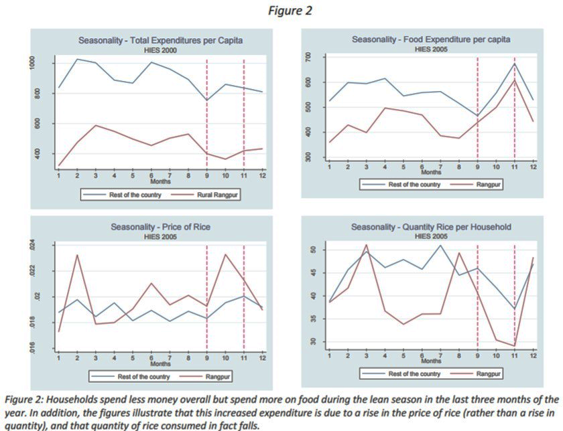
Source:Mubarak, 2016, http://faculty.som.yale.edu/mushfiqmobarak/featuredresearch/seasonal_migration.pdf
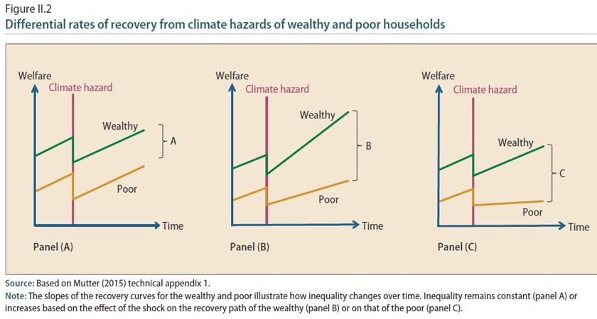

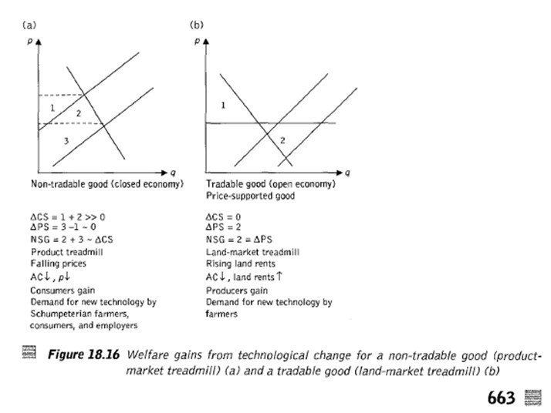
See www.gdsnet.org/DejanvrySadouletChapter18AgricDevelop.pdf

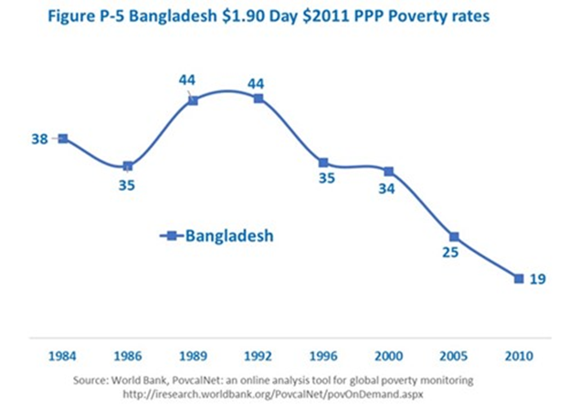

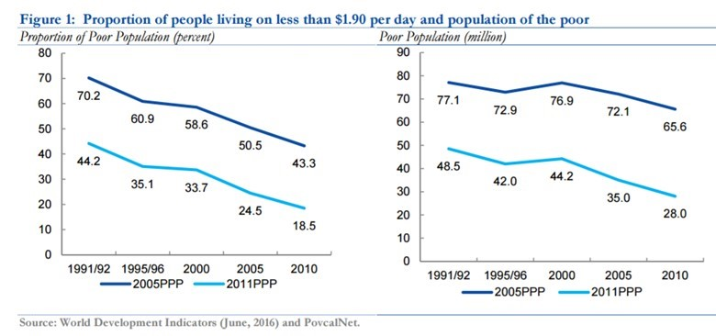

Midterm Version 1 Previous exam (for reference only)

“Attention to the role of brawn suggests that health-based development, similar to the experience in Bangladesh, will, in the absence of any other changes, increase the schooling of women relative to men, increase occupational differentiation by gender and thus differences in returns to schooling by gender, but increase the gap in earnings between men and women. Similarly, a policy that favors agricultural development - a sector in which brawn has relatively high payoffs - will augment the earnings of men, who have an absolute advantage in brawn, relative to women and increase the gender division of labor across activities. In contrast, a policy promoting openness to trade and foreign investment that changes the occupational mix in favor of jobs that are skill-intensive will augment the earnings of women relative to men, increase schooling investments by women relative to men, and lower the gap in schooling returns.” (Pitt et al. 2012 section 9)

Due to the importance of soil preparation, societies that traditionally practiced plough agriculture—rather than shifting hoe cultivation—tended to develop a specialization of production along gender lines. Men tended to work outside the home in the fields, while women specialized in activities within the home.
This division of labor then generated norms about the appropriate role of women in society. Societies characterized by plough agriculture, and the resulting gender-based division of labor, developed
a cultural belief that the natural place for women is within the home. Alesina, 2013. P. 475

- Impact evaluation and particularly randomized trials has become standard for assessing the develop policies. The goal of most of these policy experiments is to demonstrate external validity by being “scaled up” which is what happened to deworming. (a) Briefly map out the controversy surrounding Kremer and Miguel’s (2004) Econometrica paper. In your view was it too early to “scale up” mass deworming (as Givewell, 2015 and J-PAL did? Deworming should be justified on its own right (but see massive India experiment), but not listed as cheap way of improving school performance. (b) How did Jack and Suri’s analysis of MPESA’s impact and the various Progresa impact evaluations avoid these problems (including the “moral” issue identified by Roodman in his blog entry on randomized trials. (c) Why is Clemens and Sandefur (2015) to road map out of this debate incomplete? What about the 1998 Kenya El Nino problem? Has it been dealt with?

- There are several dimensions of Bangladesh’s growth miracle: agricultural, health, education, malnutrition, fertility, and exports. Gender is of course a cross-cutting issue. (a) Identify one of these topics and prepare at least 4 slides per person presenting evidence on this issue to the class (we will put these online). For example the findings brains vs. brawn Roy model tested in Bangladesh by Pitt, Rosenzweig and Hassan (2012) and by Baird et al. (in Kenya suggest health interventions and trade and export jobs favor women over men, whereas agricultural innovation favors men (“brawn”). However, Behrman et. al (2009) find no gender bias and that only “brains” or skills increase wages. (b) briefly explain the economic reasoning behind these results. Does it seem plausible that the lower “opportunity cost” of female explains increased female education? What other interventions in Bangladesh and Kenya (and Mexico) might explain increased reduced gender bias in education (c) Kabeer (2012,2017), Heath (2013) offer other explanations of increased female education. How can use the DHS for BDG to check this? Do it, put some data for BDG into your slides (for example).

Roy, Andrew Donald. "Some thoughts on the distribution of earnings." Oxford economic papers 3, no. 2 (1951): 135-146.

To Specialize or Diversify: Agricultural Diversity and Poverty Dynamics in Ethiopia Michler, J D and Josephson, A L (2017) To Specialize or Diversify: Agricultural Diversity and Poverty Dynamics in Ethiopia. World Development, 89. pp. 214-226. ISSN 0305-750X

Intensify or diversify? Agriculture as a pathway from poverty in eastern Kenya, Series Paper Number 40
Verkaart, S and Orr, A and Harris, D and Claessens, L (2017) Intensify or diversify? Agriculture as a pathway from poverty in eastern Kenya, Series Paper Number 40. [Socioeconomics Discussion Paper Series] http://oar.icrisat.org/9937/
http://oar.icrisat.org/9937/1/S_Verkaart_et_al_2017_ISEDPS_40.pdf

Welfare impacts of improved chickpea adoption: A pathway for rural development in Ethiopia?
Verkaart, S and Munyua, B G and Mausch, K and Michler, J D (2017) Welfare impacts of improved chickpea adoption: A pathway for rural development in Ethiopia? Food Policy, 66. pp. 50-61. ISSN 0306-9192

Atkin, David. "Working for the future: Female factory work and child health in mexico." Unpublished Manuscript, Yale University (2009).

Data Sources

http://www.childmortality.org/ CME Info is a database containing the latest child mortality estimates based on the research of the UN Inter-agency Group for Child Mortality Estimation.

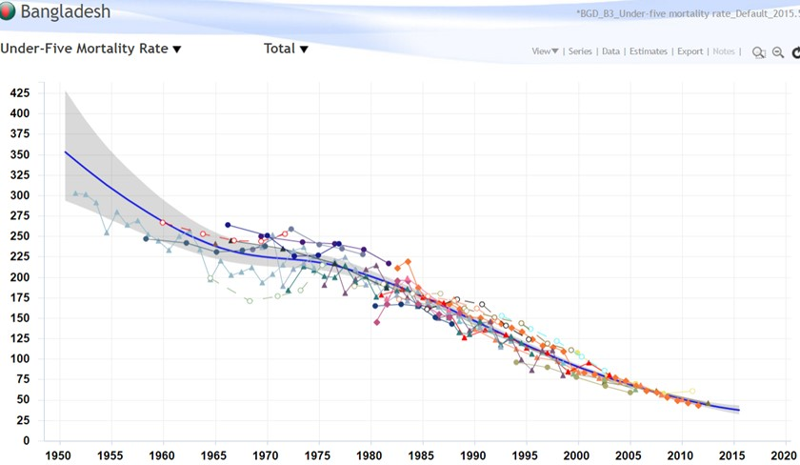

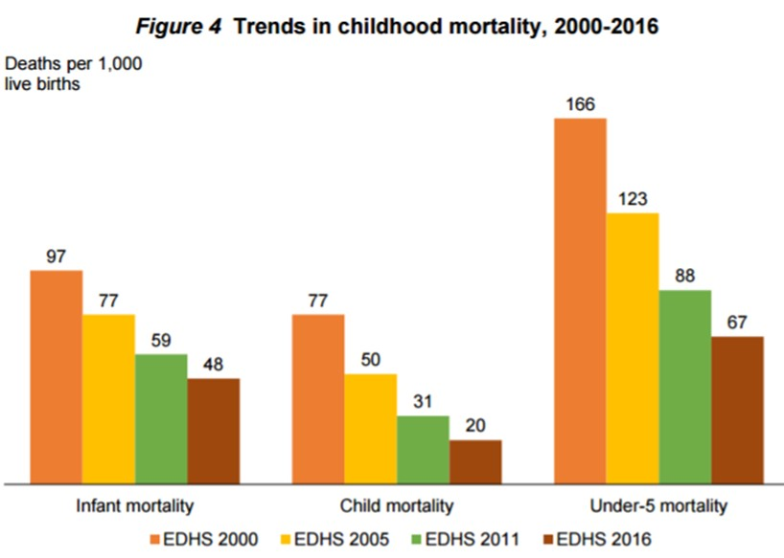
Ethiopia Child Mortality 2016 DHS: the MDG goal was a 2/3 reduction

DHS 2016 Ethiopia, https://www.usaid.gov/sites/default/files/documents/1860/Ethiopia%20DHS%202016%20KIR%20-%20Final%2010-17-2016.pdf

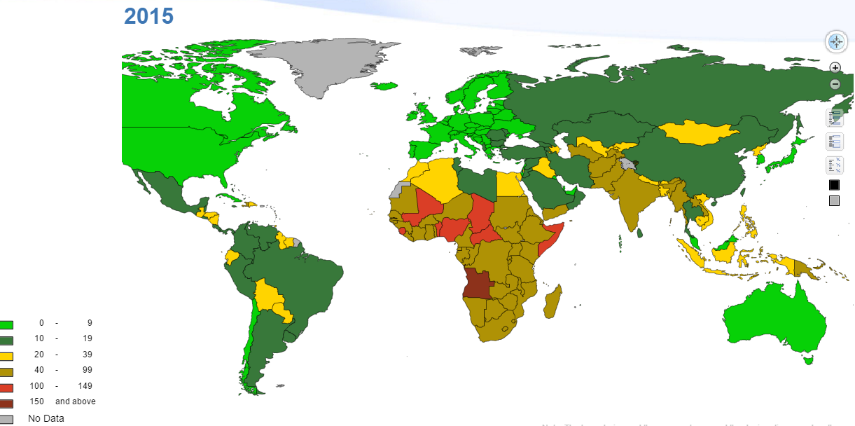

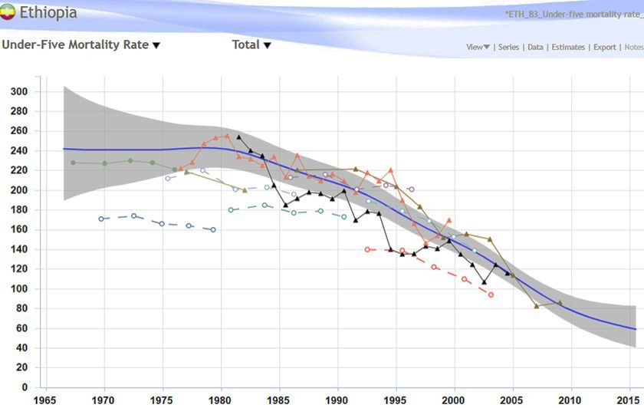

www.gdsnet.org/GenderClimateChangeLatinAmerica.pdf
www.gdsnet.org/INESADGenderEthnicityClimateChangewp07_2014.pdf
Community Development

“Build back better” was a UNDP-BCPR mandate during the 2004, see my photo of the UNDP housing project near Galle, Sri Lanka in the Resilience Lecture notes … Galle is also famous for its Fort and garment factories…
Tavneet Suri (2011) Selection And Comparative Advantage In Technology Adoption, Econometrica, Vol. 79:1 159-209.

